SNC1P Practice Test: Measurement Skills and Physical Properties Date:________

**Types of Observations:**

1. Observations can be qualitative or quantitative. Draw a line to connect each term to the best-representative symbol and explain your choice.

Term: Symbol: Explain your choice:

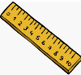Qualitative

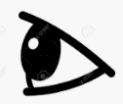

Quantitative

1. Identify each observation as QUALITATIVE OR QUANTITATIVE.

The length of the block is 15.0 cm. :____________________

The metal has a shiny lustre: ______________________

The water temperature is 30.0° C:_____________________

The powder is yellow: ____________________________

**Physical Properties**

1. Each description below refers to a physical property. Match each description to the correct physical property.

Colour Lustre State Crystal Form Texture

Hardness Malleability Ductility Viscosity Transparency

1. Salt looks like small tiny cubes: _______________
2. Polished aluminum has a shiny surface:______________
3. Tin foil is a thin flexible sheet. ____________________
4. Copper can be pulled into thin wires for electrical circuits:________________
5. The rock has a rough surface:_______________________
6. Sulfur is a bright yellow element:_______________________
7. Glass is clear:________________________
8. Maple syrup is thick and flows slowly:__________________
9. At room temperature, oxygen is a gas:___________________
10. Diamond has one of the highest hardness values:____________________
11. **Metals and Non-Metals**:

On the periodic table, metals are found on the __________ side.

On the periodic table, non-metals are found on the __________ side.

Identify each element as a METAL or NON-METAL:

*Sulfur Copper Nickel Phosphorus Oxygen Magnesium*

Match the SEVEN properties to either metals or non-metals:

**Silvery Colour Usually malleable and ductile**

**Does not conduct heat or electricity Usually brittle**

**Dull lustre Shiny lustre**

**Conducts heat or electricity**

|  |  |
| --- | --- |
| Metals: | Non-metals: |
| Properties of metals: | Properties of non-metals: |

**Volume and Density:**

**Write the formula for finding volume of a rectangular prism:**

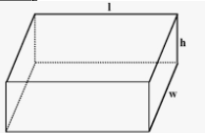 **V = ______________________**

1. A rectangular block has dimensions of 12.0 cm by 5.0 cm by 8.0 cm. Find the volume of the block.

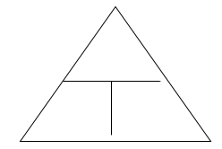

Write down the triangle to find density:

1. a) A block has dimensions of 2.5 cm by 3.0 cm by 5.0 cm. It has a mass of 101.3 grams. Find the volume and density of the block.

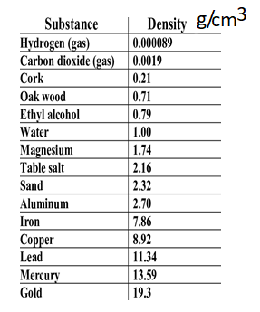

b) Given the chart below, identify the material of the block.

1. An irregular shaped rock has a mass of 69.4 g. The volume of the rock is measured by displacement. The initial water level is 150.0 mL. When the rock is placed in the water the level rises to 184.0 mL. Find the volume and density of the rock.